A Project Proposal On

“Krishibzar”

Submitted by

Pawan Bhandari (07)

Prashant Karki (17)

Shital Khatri Chetri (21)

Shashwot Thapa (40)

Abishek Yakha (42)

Submitted to

Department of Management Informatics and Communication

Kathmandu University

Dhulikhel, Kavre

April, 2023

Associate Prof Dr. Khagendra Acharya

Head of Department

Department of Management Informatics and Communication

Kathmandu University

Dhulikhel, Nepal

Subject: Formation of 5-member project group

Respected Sir,

This letter is to notify the department of formation of a 5-member project group for COM 244 (Computer Project I). We are developing a web project for vegetable and fruit sellers to connect with customers/buyers making it easier for them to sell their produce and customers to purchase items directly from the source. We needed additional manpower for the project development especially in backend during work division. To compensate this, we formed the 5-member team. We would like to assure you that, we will be working hard on the parts decided during division of work for the completion of the project.

In that regard, we hope you will understand our situation and allow the formation of this team.

Yours Sincerely,

(Team Nirvana)

Pawan Bhandari (07)

Prashant Karki (17)

Shital Khatri Chetri (21)

Shashwot Thapa (40)

Abishek Yakha (42)

Acknowledgement

We feel highly obliged and grateful to take this opportunity to sincerely express a deep sense of thanks and gratitude to the Department of Management Informatics and Communication (DoMIC), Kathmandu University (KU), School of Management (SOM) for including the project COM 244 in our syllabus. We are also thankful to our HOD Prof. Dr Khagendra Acharya to provide us with an opportunity where we can put in our hard work and dedication to explore our abilities and knowledge to create something in the field of computing. We promise to give our best in this project.

We hope that our proposal will be approved, and we will be allowed to do this project for this course from our department.

Sincerely,

(Team Nirvana)

Pawan Bhandari (07)

Prashant Karki (17)

Shital Khatri Chetri (21)

Shashwot Thapa (40)

Abishek Yakha (42)

i

Abstract

With the growing importance of online marketing, there is an opportunity to bring framers/sellers and customers closer through an online platform. Our project "Krishibzar" is to design and develop a website that will allow vegetables and fruit sellers to sell their product online by providing a direct link between vegetable and fruit seller and customers, eliminating intermediaries and reducing the cost of vegetables. Krishibzar will help farmers to increase customers base, reduce waste, and providing customers with a convenient way to purchase farmers produce. Krishibzar will allow farmers/sellers to create an account on the platform and upload their products with images, descriptions, price and location on the platform which will enable customers to browse and purchase products online. The proposed methodology involves through research, development using latest web development technologies and frameworks and testing before launching the website. This project will solely be using HTML, CSS, BOOTSTRAP, PHP and JS with its libraries and runtime environment.

Keywords: HTML, CSS, JS,PHP,BOOTSTRAP,Database, Web.

ii

Table of Contents

Acknowledgement ...........................................................................i

Abstract.............................................................................................ii

Table of Contents............................................................................ iii

Acronyms/Abbreviations..................................................................1

Chapter 1 Introduction......................................................................1

1.1 Background ................................................................................1

1.2 Objectives...................................................................................2

1.3 Motivation and Significance ......................................................2

1.4 Expected Outcomes....................................................................3

Chapter 2 literature Review……....…………………….………….3

2.1 Review of literature....................................................................3

Chapter 3 Procedure and Methods...................................................4

3.1 Research and Study....................................................................4

Chapter 4 Project Planning and Scheduling ....................................5

4.1 Budget .......................................................................................5

References........................................................................................6

ii

Acronyms/Abbreviations

The list of all abbreviations used in the documentation is included in this section.

See the example below:

|  |  |
| --- | --- |
| JS | Java Script |
| DB | Database |
| CSS | Cascading Style Sheets |
| HTML | Hyper Text Markup Language |
| UI | User Interface |
| PHP | Hypertext Preprocessor/Personal home Page |
|  |  |

Chapter 1 Introduction

1.1 Background

The agricultural sector plays significant role in the economy of many countries. In the country like Nepal, agriculture is a primary source of income for a large number of people. Despite the sectors significant contributions farmers and sellers often face a challenging in marketing their produce leading to low prices and wastage of produce.

Vegetable and fruit sellers in many parts of the world still relay on traditional methods of selling their produce, which can be time consuming and inefficient. Additionally, customers often have to go through intermediaries or middleman to purchase vegetables which can lead to higher prices and lower quality produce. Our platform "Krishibzar" aims to bridge this gap by providing a direct link between vegetables sellers and customers, which will be more cost-effective, efficient and convenient for both parties.

1

1.2 Objectives

The main objectives of our application are as follows:

1. To design and implement a user-friendly e-commerce website for selling fruits and vegetables.
2. To improve the efficiency of sales and distribution by leveraging digital technology.
3. To provide direct link between vegetable and fruit seller/farmers and customers, eliminating intermediaries or middleman.
4. To allow farmers/sellers to upload their products with images, descriptions, price and location on the platform which will enable customers to browse and purchase products online.
5. To help farmers expand their customers base, increase sales and reduce waste and cost.

1.2 Motivation and Significance

Any big project is a collaborative process. For the successful completion of a project, all members need to do their fair share of work and contribute for work done on time. The motivation behind this project is to address the challenges faced by the farmers and sellers in marketing their produce by the online platform in this digital age. By developing a website that connect farmers/sellers with potential customers, we hope to promote the growth of the agricultural sector and reduce wastage produce. This project aims to provide an innovative solution to address these challenges and somehow contribute to the growth of the agricultural sector. The significance of this project lies in it’s potential to benefit farmers, sellers, and customers alike.

2

1.3 Expected Outcomes

Krishibzar will create a platform where user can create an account and after that they can sell their products related to vegetable/fruits where various customers can buy their products. It will provide descriptions of product, price, location, quantity, payment system and other related information so that the customers can buy product in online method. It will help to improved income for farmers and sellers and contribute to the growth of the agricultural sector by providing an innovative solution to address the challenges faced by small scale farmers in accessing markets to sell their products.

Chapter 2 Literature Review

A literature review is a concise overview of what has been studied, argued and established about a topic. It entails about the major findings as well as reviewing the tools and techniques used by the previous studies. This chapter provides review of related literature.

2.1 Review of Literature

“E-commerce in agriculture” by A. Roy et al., published in the international journal of engineering and technology (2018): This article provides an overview of the potential benefits and challenges of e-commerce in the agriculture sector, and discusses various e-commerce models that have been used in different countries. The authors argue that e-commerce can help to increase market access for small-scale farmers.

"Agricultural E-commerce and Its Development Strategy" by Wei Hu, published in the Journal of Economics and Sustainable Development (2015): This article examines the potential benefits and challenges of agricultural e-commerce in China, with a focus on the direct selling model. The author argues that e-commerce can help farmers bypass intermediaries and reach consumers more efficiently

3

Chapter 3 Procedure and Methods

4.1 Research and study

Proper research and explanation are needed before performing any tasks. We have thought of this project idea for quite a long time and planned to implement it on a semester project. First, we will conduct extensive research and study on the current market trends, customers behavior, and the requirements of farmers and sellers. This will involve the collection of data through surveys and interviews with farmers, sellers, and potential customers. We will also conduct a thorough analysis of existing websites to identify areas we that need improvement and to incorporate innovative features that will make our website stand out.

Then, we decided what platform we are going to use to develop this project. After the platform was finalized, we decided to divide the part in two ways: FrontEnd and BackEnd. People with interest in FrontEnd started to study and research FrontEnd and People with BackEnd interest started to study BackEnd as well as project management, test planning and analysis document is to be done by the team mates.

4.1.1 Testing and Debugging

To make our work productive, we will be developing and testing the system from the very beginning. It is a website. I think it will be easier to test and debug the site. Also, we will be consulting our supervisor for the queries that arise.

● Documentation

We will be filling out log sheets regularly to view progress and make our work organized. Further report is made after completion of project.

4

Chapter 4 Project Planning and Scheduling

Being new to web development, we have to adapt ourselves by learning it first and then practicing. Since we are completing this project in 12 weeks time, we decided to divide the project period as:

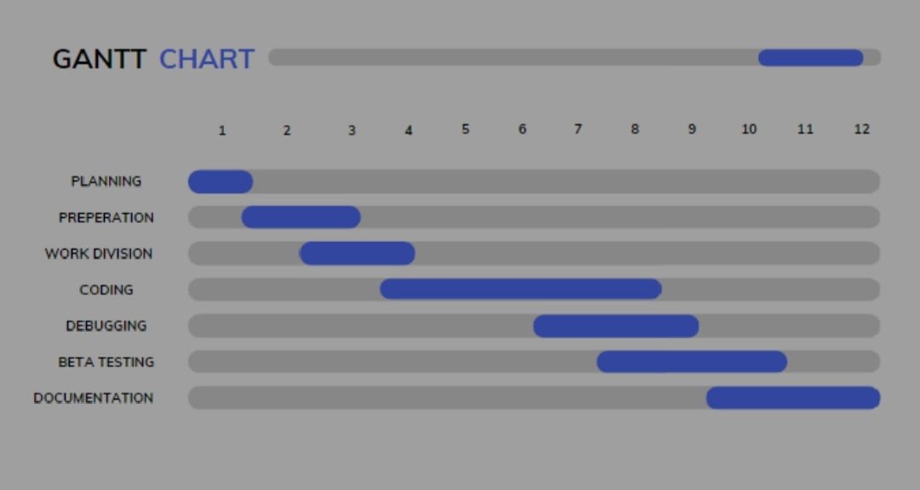

* 1. Budget for the project:

|  |  |
| --- | --- |
| Description | Amount (in Rs) |
| FGD’s and Market Research/Surveys Expenses | 4000 |
| Printings and Paperwork | 5000 |
| Project Meetings and Discussion Expenses | 5000 |
| Domain Registration | 2000 |
| Others related to server, networking, storage,host services etc | 10,000 |
| Total | 26,000 |

5

References

1. https://www.google.com/search?q=google+scholar&oq=google+s&aqs=chrome.1.69i57j69i59j0i131i433i512j0i20i263i512j69i60l3j5.8228j0j7&sourceid=chrome&ie=UTF-8
2. https://www.google.com/search?q=web+development&oq=we&aqs=chrome.1.69i57j69i59j35i39i650j0i67i650j0i67i131i433i650j69i60j69i61l2.3202j0j7&sourceid=chrome&ie=UTF-8

6